**Laboratory 2 of Electrotechnics and Electrical Machines**

**Antohi Andi Ionel, Navigation, group 211C**

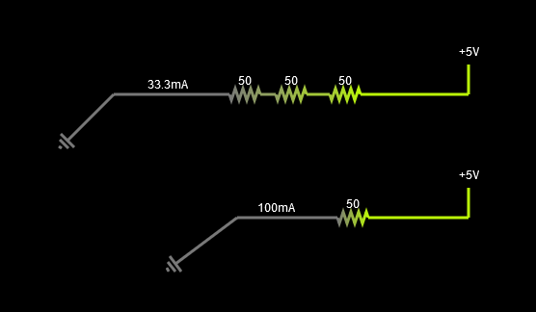

**Series Resistance Formula (RS) / equivalents for 3 resistors: R1 + R2 + R3..**

**The first drawing:**

* **Voltage U: 5V**
* **The intensity of direct electric current: 33.3 mA**
* **Series resistance (Rs) / equivalent -> R1 + R2 + R3 :** 50 + 50 + 50 = 150 Ω

**The second drawing:**

* **Voltage U: 5V**
* **The intensity of direct electric current: 100 mA**
* **Equivalent resistance -> R: 50 Ω**